

COURSE NAME

**Introduction To Database**

PROJECT NAME

**Coffee Shop Management**

**Scenario**

A coffee shop must have a name, an address, a phone number, a shop registration number, and an email address. The coffee shop's proprietor is recognized by his or her name, address, phone number, and email address. The owner appoints a manager to oversee staff retention. Employees are identified by their unique identifier, name, phone number, address, email address, salary, and date of hiring. These details are also sent on to the management. The system also keeps track of the names of the customers. Customers pay the bill, which includes the bill number, description, time, and date, as well as the total amount. A coffee shop management system may be organized by following these guidelines.

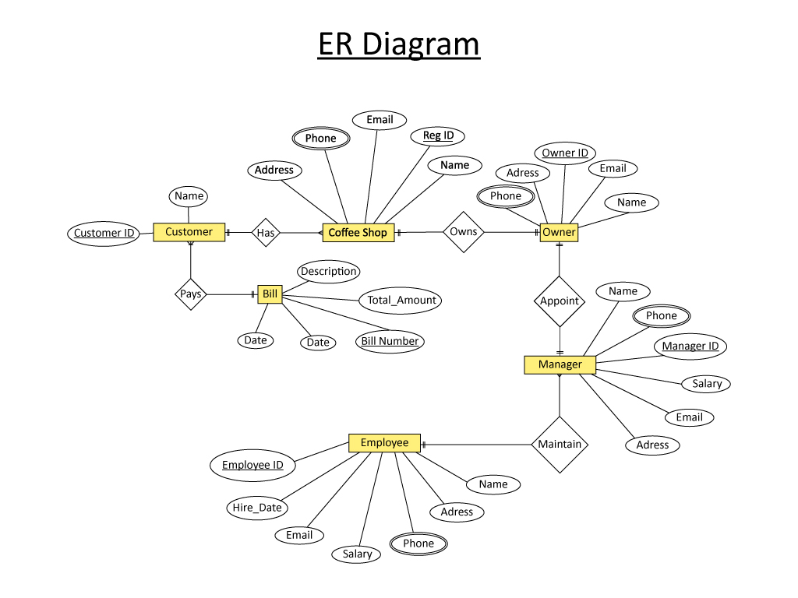

**NORMALIZATION:**

**OWNS**

|  |  |  |  |  |  |  |  |  |  |
| --- | --- | --- | --- | --- | --- | --- | --- | --- | --- |
| Reg_id | address | Phone | Email | name | O_id | Name | phone | email | address |

1NF:

|  |
| --- |
| PHONE |

2NF:

|  |  |  |  |  |  |
| --- | --- | --- | --- | --- | --- |
| REGI_ID | NAME | ADDRESS | PHONE | EMAIL | O_ID |

|  |  |  |  |  |
| --- | --- | --- | --- | --- |
| O_ID | NAME | EMAIL | PHONE | ADDRESS |

3NF:

|  |  |  |  |  |  |
| --- | --- | --- | --- | --- | --- |
| REGI_ID | NAME | ADDRESS | PHONE | EMAIL | O_ID |

|  |  |  |  |  |
| --- | --- | --- | --- | --- |
| O_ID | NAME | EMAIL | PHONE | ADDRESS |

TABLE:

1.

|  |  |  |  |  |  |
| --- | --- | --- | --- | --- | --- |
| REGI_ID | NAME | ADDRESS | PHONE | EMAIL | O_ID |

2.

|  |  |  |  |  |
| --- | --- | --- | --- | --- |
| O_ID | NAME | EMAIL | PHONE | ADDRESS |

appoint:

|  |  |  |  |  |  |  |  |  |  |  |
| --- | --- | --- | --- | --- | --- | --- | --- | --- | --- | --- |
| O_id | name | phone | email | address | m_id | phone | name | address | email | salary |

1nf:

**PHONE**

2NF:

|  |  |  |  |  |
| --- | --- | --- | --- | --- |
| O_id | Phone | Email | Name | address |

|  |  |  |  |  |  |  |
| --- | --- | --- | --- | --- | --- | --- |
| M_ID | NAME | PHONE | SALARY | ADDRESS | EMAIL | O_ID |

3NF:

|  |  |  |  |  |
| --- | --- | --- | --- | --- |
| O_id | Phone | Email | Name | address |

|  |  |  |  |  |  |  |
| --- | --- | --- | --- | --- | --- | --- |
| M_ID | NAME | PHONE | SALARY | ADDRESS | EMAIL | O_ID |

TABLE:

1.

|  |  |  |  |  |
| --- | --- | --- | --- | --- |
| O_id | Phone | Email | Name | address |

2.

|  |  |  |  |  |  |  |
| --- | --- | --- | --- | --- | --- | --- |
| M_ID | NAME | PHONE | SALARY | ADDRESS | EMAIL | O_ID |

**MAINTAIN:**

|  |  |  |  |  |  |  |  |  |  |  |  |  |
| --- | --- | --- | --- | --- | --- | --- | --- | --- | --- | --- | --- | --- |
| M_ID | NAME | PHONE | SALARY | ADDRESS | EMAIL | e_ID | NAME | ADDRESS | EMAIL | PHONE | SALARY | HIRE_DATE |

1NF:

**PHONE**

2NF:

|  |  |  |  |  |  |  |
| --- | --- | --- | --- | --- | --- | --- |
| M_ID | NAME | PHONE | SALARY | ADDRESS | EMAIL | e_ID |

|  |  |  |  |  |  |  |
| --- | --- | --- | --- | --- | --- | --- |
| e_ID | NAME | ADDRESS | EMAIL | PHONE | SALARY | HIRE_DATE |

3NF:

|  |  |  |  |  |  |  |
| --- | --- | --- | --- | --- | --- | --- |
| M_ID | NAME | PHONE | SALARY | ADDRESS | EMAIL | e_ID |

|  |  |  |  |  |  |  |
| --- | --- | --- | --- | --- | --- | --- |
| e_ID | NAME | ADDRESS | EMAIL | PHONE | SALARY | HIRE_DATE |

**TABLE:**

1.

|  |  |  |  |  |  |  |
| --- | --- | --- | --- | --- | --- | --- |
| M_ID | NAME | PHONE | SALARY | ADDRESS | EMAIL | e_ID |

2.

|  |  |  |  |  |  |  |
| --- | --- | --- | --- | --- | --- | --- |
| e_ID | NAME | ADDRESS | EMAIL | PHONE | SALARY | HIRE_DATE |

**HAS:**

|  |  |  |  |  |  |  |
| --- | --- | --- | --- | --- | --- | --- |
| REGI_ID | NAME | ADDRESS | EMAIL | PHONE | C_ID | NAME |

1NF:

PHONE

2NF:

|  |  |  |  |  |  |
| --- | --- | --- | --- | --- | --- |
| REGI_ID | NAME | ADDRESS | EMAIL | PHONE | C_ID |

|  |  |
| --- | --- |
| C_ID | NAME |

3NF:

|  |  |  |  |  |  |
| --- | --- | --- | --- | --- | --- |
| REGI_ID | NAME | ADDRESS | EMAIL | PHONE | C_ID |

|  |  |
| --- | --- |
| C_ID | NAME |

**TABLE:**

1.

|  |  |  |  |  |  |
| --- | --- | --- | --- | --- | --- |
| REGI_ID | NAME | ADDRESS | EMAIL | PHONE | C_ID |

2.

|  |  |
| --- | --- |
| C_ID | NAME |

**PAYS:**

|  |  |  |  |  |  |
| --- | --- | --- | --- | --- | --- |
| C_ID | NAME | BILL_NUMBER | DESCRIPTION | TOTALAMOUNT | DATE |

1NF:

NO MULTI VALUED ATTRIBUTE

2NF:

|  |  |  |
| --- | --- | --- |
| C_ID | NAME | BILL_NUMBER |

|  |  |  |  |
| --- | --- | --- | --- |
| BILL_NUMBER | DESCRIPTION | TOTALAMOUNT | DATE |

3NF:

|  |  |  |
| --- | --- | --- |
| C_ID | NAME | BILL_NUMBER |

|  |  |  |  |
| --- | --- | --- | --- |
| BILL_NUMBER | DESCRIPTION | TOTALAMOUNT | DATE |

TABLE:

1.

|  |  |  |
| --- | --- | --- |
| C_ID | NAME | BILL_NUMBER |

2.

|  |  |  |  |
| --- | --- | --- | --- |
| BILL_NUMBER | DESCRIPTION | TOTALAMOUNT | DATE |

**TOTAL TABLE**

1.

|  |  |  |  |  |  |
| --- | --- | --- | --- | --- | --- |
| REGI_ID | NAME | ADDRESS | PHONE | EMAIL | O_ID |

2.

|  |  |  |  |  |
| --- | --- | --- | --- | --- |
| O_ID | NAME | EMAIL | PHONE | ADDRESS |

3.

|  |  |  |  |  |
| --- | --- | --- | --- | --- |
| O_id | Phone | Email | Name | address |

4.

|  |  |  |  |  |  |  |
| --- | --- | --- | --- | --- | --- | --- |
| M_ID | NAME | PHONE | SALARY | ADDRESS | EMAIL | O_ID |

5.

|  |  |  |  |  |  |  |
| --- | --- | --- | --- | --- | --- | --- |
| M_ID | NAME | PHONE | SALARY | ADDRESS | EMAIL | e_ID |

6.

|  |  |  |  |  |  |  |
| --- | --- | --- | --- | --- | --- | --- |
| e_ID | NAME | ADDRESS | EMAIL | PHONE | SALARY | HIRE_DATE |

7.

|  |  |  |  |  |  |
| --- | --- | --- | --- | --- | --- |
| REGI_ID | NAME | ADDRESS | EMAIL | PHONE | C_ID |

8.

|  |  |
| --- | --- |
| C_ID | NAME |

9.

|  |  |  |
| --- | --- | --- |
| C_ID | NAME | BILL_NUMBER |

10.

|  |  |  |  |
| --- | --- | --- | --- |
| BILL_NUMBER | DESCRIPTION | TOTALAMOUNT | DATE |

**FINAL TABLE:**

1.

|  |  |  |  |  |
| --- | --- | --- | --- | --- |
| O_id | Phone | Email | Name | address |

2.

|  |  |  |
| --- | --- | --- |
| C_ID | NAME | BILL_NUMBER |

3.

|  |  |  |  |
| --- | --- | --- | --- |
| BILL_NUMBER | DESCRIPTION | TOTALAMOUNT | DATE |

4.

|  |  |  |  |  |  |  |
| --- | --- | --- | --- | --- | --- | --- |
| e_ID | NAME | ADDRESS | EMAIL | PHONE | SALARY | HIRE_DATE |

5.

|  |  |  |  |  |  |  |
| --- | --- | --- | --- | --- | --- | --- |
| REGI_ID | NAME | ADDRESS | PHONE | EMAIL | O_ID | C_ID |

6.

|  |  |  |  |  |  |  |  |
| --- | --- | --- | --- | --- | --- | --- | --- |
| M_ID | NAME | ADDRESS | PHONE | EMAIL | SALARY | O_ID | E_ID |